**Use case diagram**

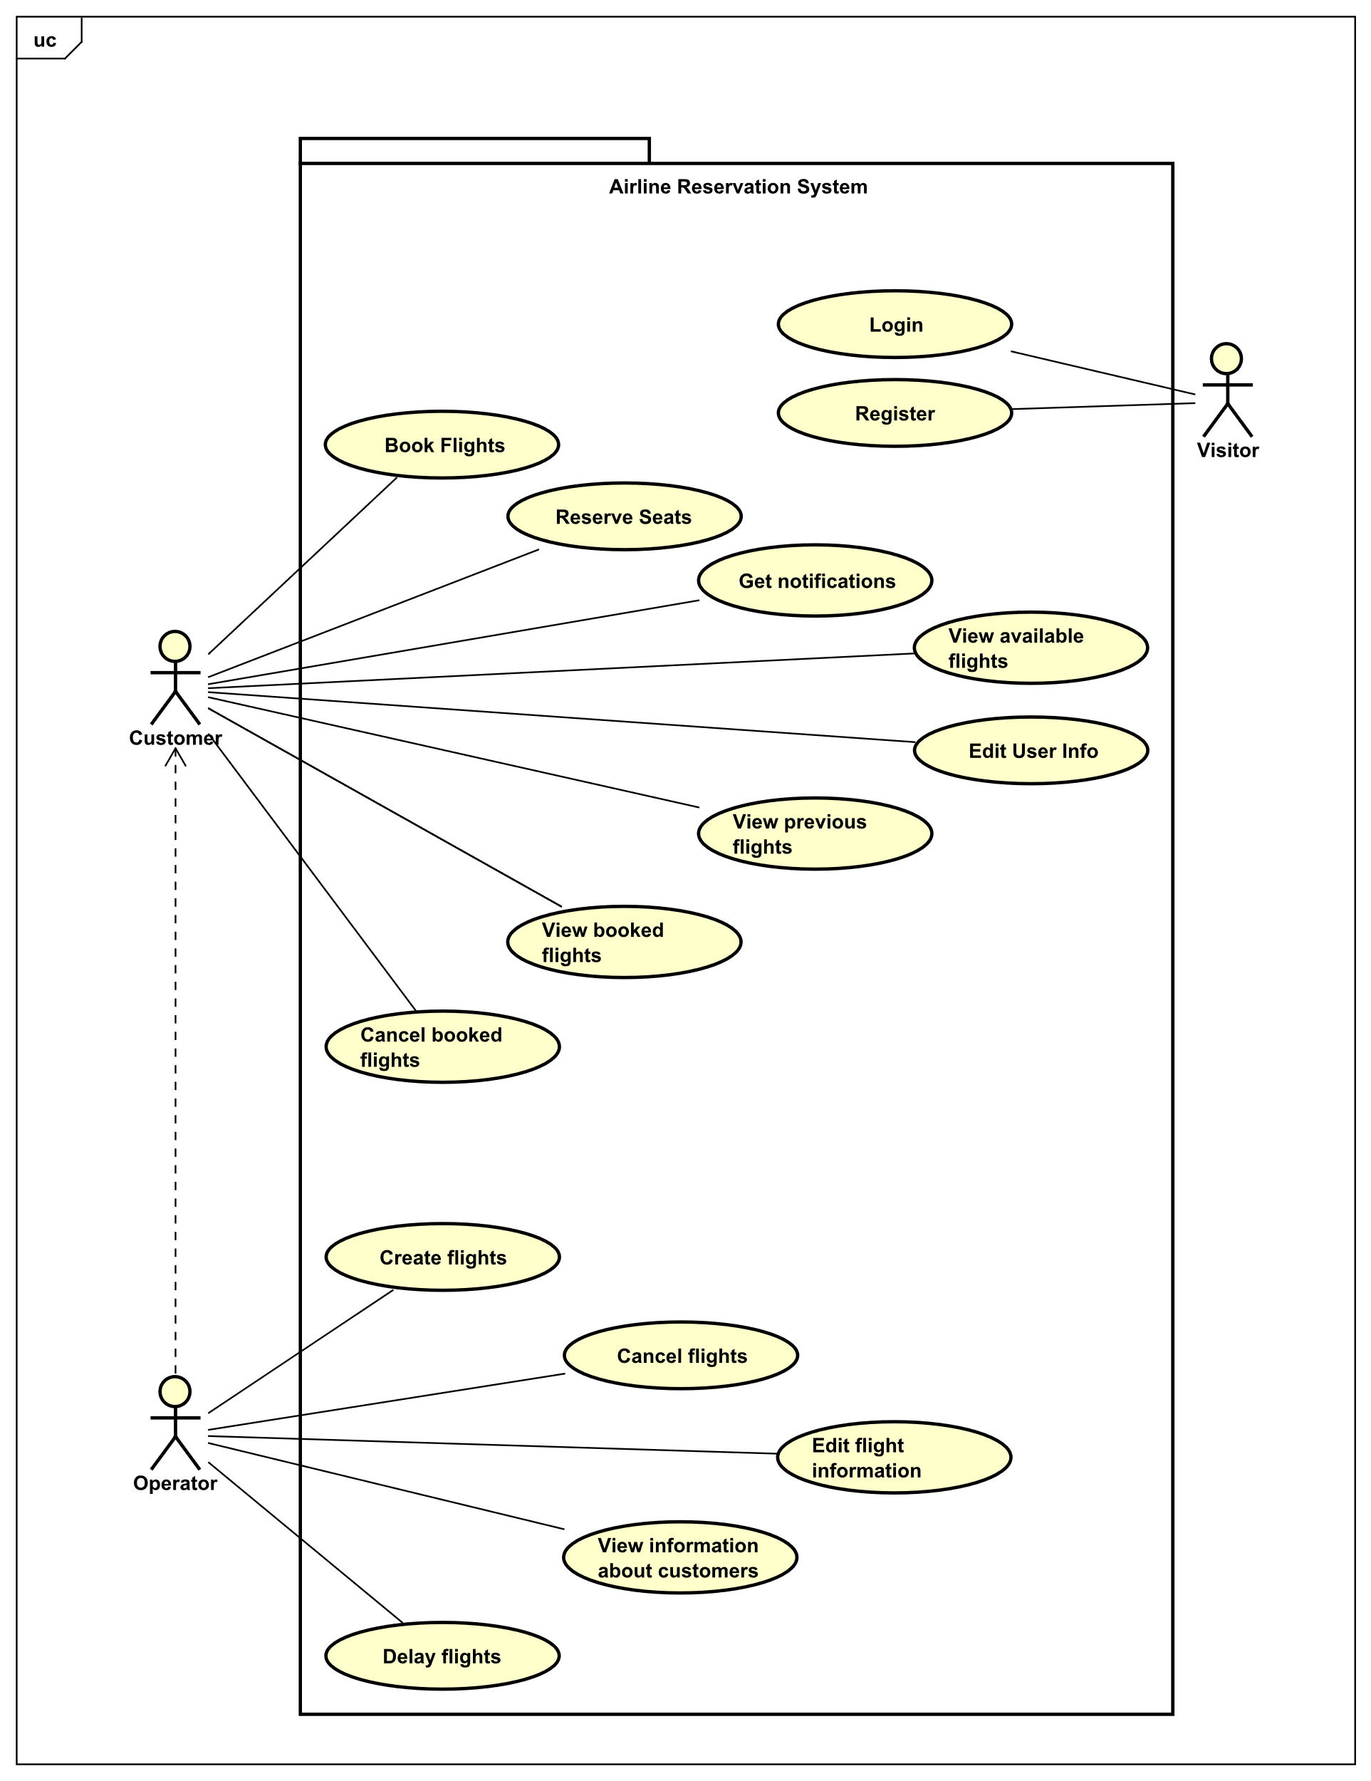

**Use case descriptions**

**Login**

|  |  |
| --- | --- |
| **Use case** | Login |
| **Summary** | Visitor log ins into the system |
| **Actor** | Visitor |
| **Precondition** | The customer already has an account registered |
| **Postcondition** | The customer is logged in the system |
| **Main scenarios** | 1. The visitor provides username and password  2. The system validates the customer’s username and password |
| **Alternative scenarios** | 2a The systems fails to validate credentials   1. The system signals an error and prompts for new credentials 2. The use case proceeds from (1) |

**Register**

|  |  |
| --- | --- |
| **Use case** | Register |
| **Summary** | The visitor signs up into library system |
| **Actor** | Visitor |
| **Precondition** | Visitor has a unique username, password, passport/id numbers and expiry date. |
| **Postcondition** | The visitor’s account was created, and visitor can log into the system as a customer |
| **Main scenarios** | 1. Visitors provides his/her information as a CPR, password, name, address and credit card information  2. System validates data  3. Visitor’s account was created |
| **Alternative scenarios** | At any time during step 1 visitor cancels  1. The use case ends  2a The account already exists  1. System informs visitor, that system already exists  2b visitor’s information are invalid  1. System informs visitor, that his/her data are not valid |

**Book flight**

|  |  |
| --- | --- |
| **Use case** | Book flight |
| **Summary** | The customer can book a flight |
| **Actor** | Customer |
| **Precondition** | Customer must be logged into their account and the flight must have available seats |
| **Postcondition** | The chosen flight is booked |
| **Main scenarios** | 1. The customer chooses the flight that they want to book.  2. The system shows details regarding the flight.  3. The customer books seats.  4. The customer selects what type of luggage they want to bring.  5. The customer purchases the ticket.  6. The system generates an unique code for the ticket purchase. |
| **Alternative scenarios** | At any time during step 1 customer cancels  1. The use case ends  3a The customer does not want to reserve desired seats  1. System chooses a random seat for the customer. |

**View available flights**

|  |  |
| --- | --- |
| **Use case** | View available flights |
| **Summary** | View flights available for customer |
| **Actor** | Customer |
| **Precondition** | Flights must be added by operator into the system and dates of the flights are in the future |
| **Postcondition** | Flights are viewed to the customer |
| **Main scenario** | 1. Customer inputs departure from 2. Customer inputs flight destination 3. Customer inputs departure date 4. Customer inputs 5. System shows a list of all available flights with those constrains |
| **Alternate Scenario** | If there are no data stored, continue from 1.  If the system cannot find item with specific attribute, system will show an error message. |

**Get notifications**

|  |  |
| --- | --- |
| **Use case** | Get notifications |
| **Summary** | Customer gets notified by system |
| **Actor** | Customer |
| **Precondition** |  |
| **Postcondition** |  |
| **Main scenario** |  |
| **Alternate Scenario** |  |

**Cancel booked flights**

|  |  |
| --- | --- |
| **Use case** | Cancel booked flights |
| **Summary** | Customer cancels their booked flights |
| **Actor** | Customer |
| **Precondition** | Flight must be booked by the customer |
| **Postcondition** | Flight is no longer booked for the specific customer |
| **Main scenario** | 1. Customer views booked flights 2. Customer selects the booked flight to be cancelled 3. Customer cancells the flight 4. System shows confirmation prompt 5. Customer will confirm that the customer wants to cancel that particular booked flight 6. System will notify user that the flight is no longer booked 7. System will delete booked code, generated for customer |
| **Alternate Scenario** | *a At any time during step 1,2,3 & 4 Customer cancels  1. The use case ends |

**Edit user info**

|  |  |
| --- | --- |
| **Use case** | Edit user info |
| **Summary** | The customer manages their account |
| **Actor** | Customer |
| **Precondition** | Customer must have account |
| **Postcondition** | Changes made by customer are saved |
| **Main scenario** | 1. The customer chooses to change the value for:   a. Full name  b. Password  c. Address  d. Date of birth  e. Passport/Id number  f. Passport/Id expiration date  g. Nationality  h. Gender  i. Phone number  j. Email address  k. Credit card info   1. System will confirm that info has been edited |
| **Alternate Scenario** | 1a The entered value is the same as previous value  1.No change has been made |